**How Does FitSmart Fat Burner Work?**

FitSmart Fat Burner is designed to work in several ways to support weight loss:

**1. Boosts Metabolism**

By using ingredients like caffeine, green tea extract, and capsicum, FitSmart Fat Burner aims to increase your metabolic rate. This means your body burns more calories even at rest, helping you create the calorie deficit needed for weight loss.

[**(OFFICIAL WEBSITE) Click Here To Order From The Official Website and Get the Lowest Price Online!**](https://www.ketogummies.xyz/get-fitsmart-fat-burn)

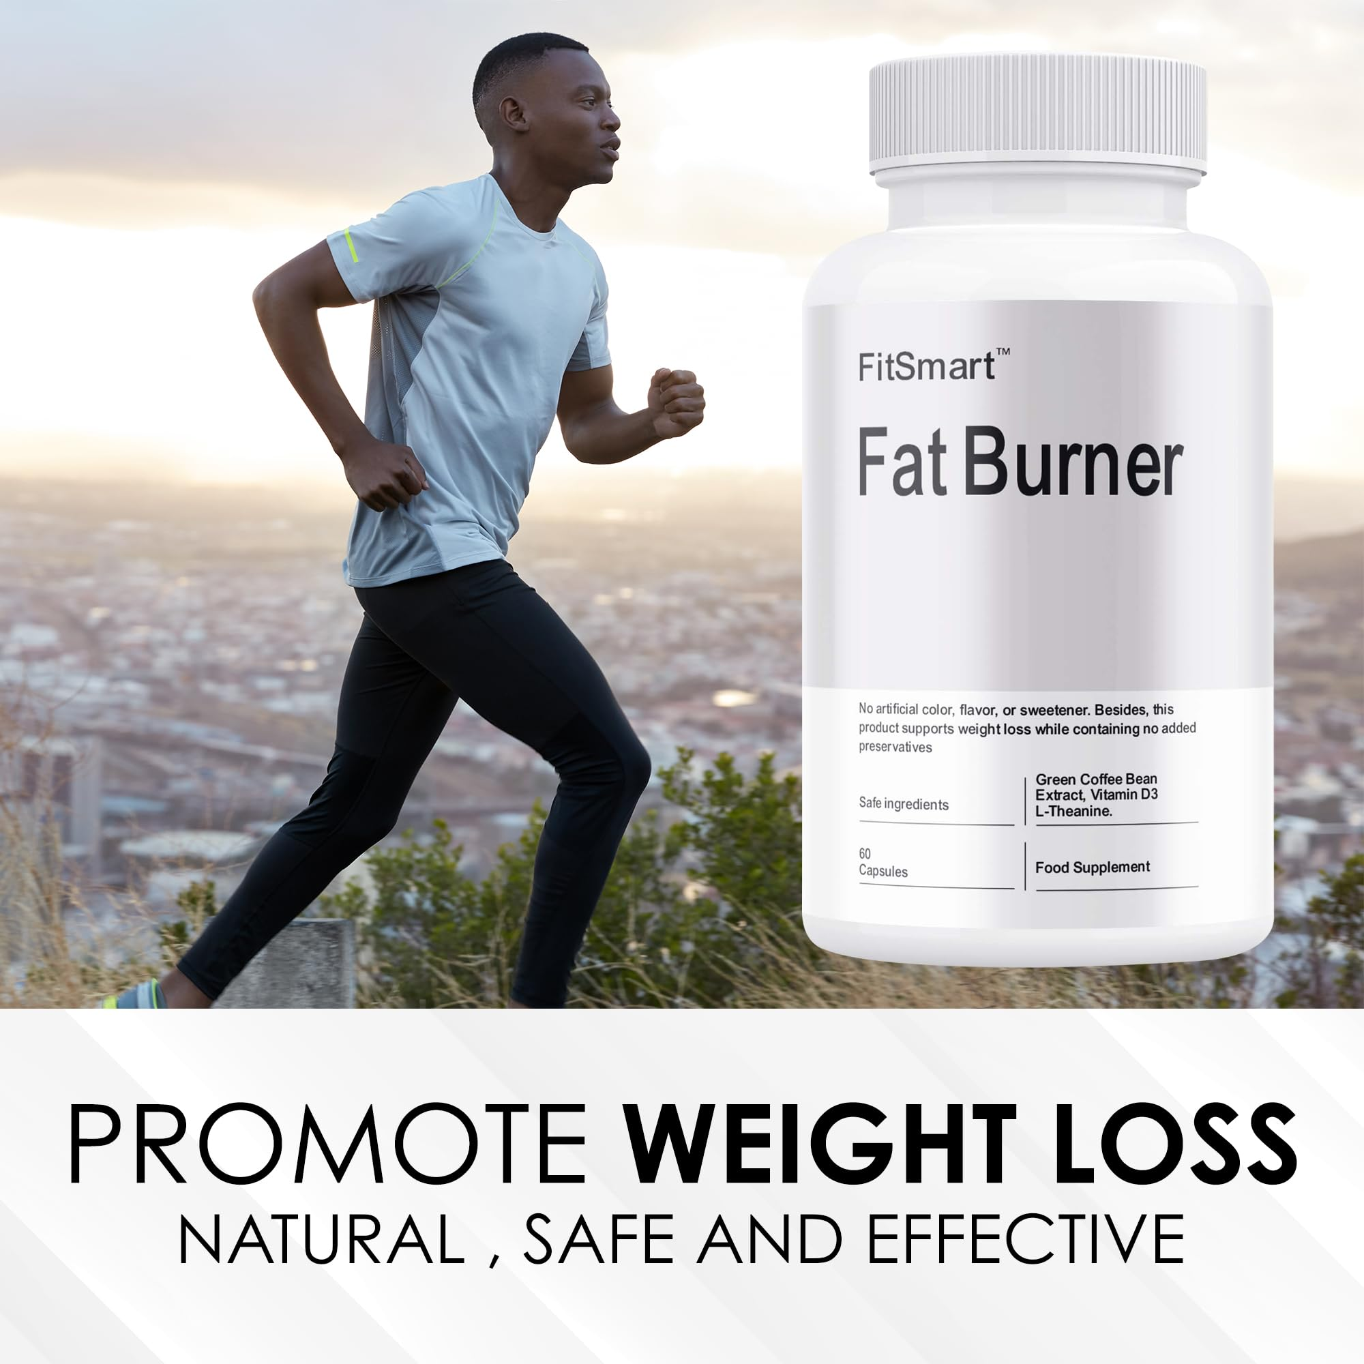

**2. Promotes Thermogenesis**

Ingredients like caffeine and capsicum stimulate thermogenesis, which raises your body temperature and encourages fat burning. This effect can help accelerate fat loss, especially when combined with exercise.

**3. Increases Energy**

Caffeine and L-Carnitine work together to enhance your energy levels, making it easier to stay active and perform better during workouts. Increased energy can also help you stay more focused and motivated throughout the day, especially when following a calorie-restricted diet.

**4. Suppresses Appetite**

Some of the ingredients, like Garcinia cambogia and capsicum, are known for their appetite-suppressing properties. This can help reduce cravings and prevent overeating, making it easier to stick to your diet.

[**(OFFICIAL WEBSITE) Click Here To Order From The Official Website and Get the Lowest Price Online!**](https://www.ketogummies.xyz/get-fitsmart-fat-burn)

**Benefits of FitSmart Fat Burner**

FitSmart Fat Burner offers several potential benefits for those looking to enhance their weight loss journey:

* **Increased Calorie Burn**: By boosting metabolism and promoting thermogenesis, the product helps the body burn more calories, even when at rest.
* **Enhanced Fat Burning**: FitSmart Fat Burner includes ingredients like L-Carnitine and green tea extract, which are known to support fat oxidation, meaning your body uses stored fat for energy.
* **Improved Energy Levels**: The caffeine content provides a significant energy boost, which can improve exercise performance and help you stay active throughout the day.
* **Appetite Control**: Ingredients like Garcinia cambogia may help reduce hunger and cravings, making it easier to maintain a calorie deficit.

**Potential Side Effects of FitSmart Fat Burner**

While FitSmart Fat Burner contains natural ingredients, it’s important to be aware of potential side effects, particularly if you’re sensitive to stimulants like caffeine or Yohimbine.

* **Jitters and Anxiety**: The high caffeine content may cause nervousness, jitters, or anxiety, especially in individuals who are sensitive to stimulants. It’s best to avoid other sources of caffeine while taking this supplement.
* **Insomnia**: Taking FitSmart Fat Burner too late in the day could interfere with sleep due to its stimulant ingredients. It’s recommended to take the supplement earlier in the day to avoid sleep disruption.
* **Increased Heart Rate**: Yohimbine can increase heart rate and blood pressure, which may be a concern for individuals with cardiovascular issues. Consult with a healthcare professional if you have any pre-existing conditions.
* **Digestive Issues**: Some users may experience mild digestive issues, such as nausea or an upset stomach, due to the high potency of some ingredients.

**How to Use FitSmart Fat Burner**

For best results, it’s recommended to follow the dosage instructions on the product label. Generally, fat burners like FitSmart are taken once or twice a day, usually before meals or workouts.

[**(OFFICIAL WEBSITE) Click Here To Order From The Official Website and Get the Lowest Price Online!**](https://www.ketogummies.xyz/get-fitsmart-fat-burn)

Here are a few tips to maximize the effectiveness of FitSmart Fat Burner:

* **Pair with a Balanced Diet**: While FitSmart Fat Burner can enhance fat loss, it’s not a magic pill. For optimal results, it’s important to maintain a calorie-controlled diet rich in whole foods, lean proteins, healthy fats, and complex carbohydrates.
* **Stay Hydrated**: Drinking plenty of water is essential, especially when taking a fat burner that contains stimulants. Proper hydration can help support metabolism and prevent side effects like jitters.
* **Exercise Regularly**: Physical activity is key to losing weight and building muscle. FitSmart Fat Burner is most effective when combined with a regular exercise routine that includes both cardio and strength training.

**Is FitSmart Fat Burner Right for You?**

FitSmart Fat Burner may be a helpful tool for individuals looking to boost their weight loss efforts, especially if they struggle with low energy, slow metabolism, or food cravings. However, it’s important to remember that no supplement can replace a healthy diet and exercise plan.

Before adding FitSmart Fat Burner to your routine, it’s a good idea to consult with a healthcare professional, especially if you have any pre-existing conditions or sensitivities to stimulants.

**Conclusion: Does FitSmart Fat Burner Deliver Results?**

FitSmart Fat Burner offers a promising blend of natural ingredients that target multiple aspects of weight loss, including metabolism, fat burning, appetite suppression, and energy levels. For individuals who are committed to a healthy diet and regular exercise, FitSmart may provide that extra boost needed to accelerate fat loss.

[**(OFFICIAL WEBSITE) Click Here To Order From The Official Website and Get the Lowest Price Online!**](https://www.ketogummies.xyz/get-fitsmart-fat-burn)

However, like all supplements, individual results may vary, and it's essential to maintain realistic expectations. While FitSmart Fat Burner can enhance your weight loss journey, long-term success ultimately depends on your lifestyle choices and commitment to a healthy, sustainable routine.